**44-560 - Adv Topics in DB Systems**

**Assignment 01 (ER Review)**

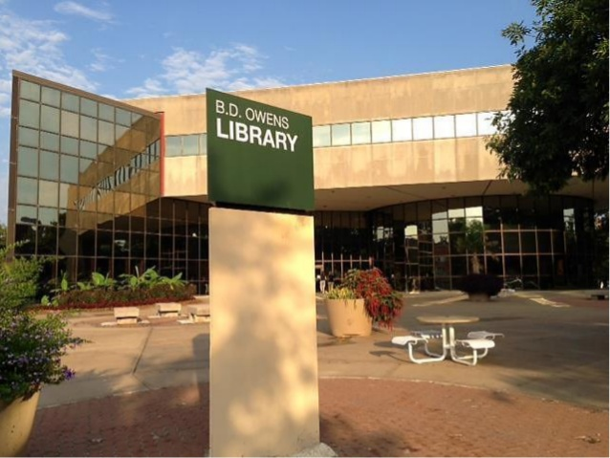

Use an ER Diagramming tool, such as LucidChart, to create an ER model for the following scenario.

**Scenario:**The [B. D. Owens Library](https://www.nwmissouri.edu/library/) of the Northwest Missouri State University has asked you to design a database that will keep track of the books, publishers and students who borrowed the books.

**Entities and attributes:**

BOOK: The B. D. Owens Library wants to keep track of all the books that currently possess and those that are lent to students. The BOOK entity stores the book name, book ID, genre, author name, price, and availability flag.

PUBLISHER: Every book has a publisher. The PUBLISHER entity holds information about all the publishers of the books in the library. It has to store the publisher name, publisher ID, phone, email address, and physical address.

STUDENT: Students have a privilege to lend books that are available. The STUDENT entity must keep track of all the students who have borrowed books. This entity contains the student’s name, unique 919 number, email address, physical address, issue date, due date, and return date.

LIBRARIAN: Every book is issued by one and only one librarian. The l LIBRARIAN entity should store the librarian’s name, ID, mobile number, email address, and physical address.

**Relationships:**

**Every book has at least one, usually many, publishers; and every publisher must have published none or many books.**

**Every book might have been borrowed by zero or more students; and each student might have borrowed zero or more books.**

Each librarian might have issued many books or might not have issued any books at all but each book must have been issued by one and only one librarian.

**Notes:**

Please identify the primary and foreign keys in the entities.

Please check rubrics before turning in this assignment.

Show associative entities where applicable.

Differentiate strong and weak relationships in the ER diagram using the appropriate representation.

For all addresses, in this assignment and future assignments, use the following format unless specifically indicated otherwise:

address_line_1

address_line_2

city

state_or_region

postal_code

country

You must use Northwest Online to turn this assignment in via upload.

**To Submit:**

Download the LucidChart file as an image file (either .jpeg or .png).

Rename the file as your Lastname_Assignment01.png (where Lastname is your lastname) and submit the renamed image file.